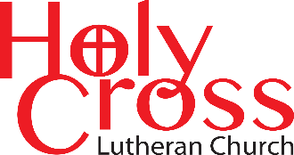
May 2026

We are transformed in Christ
to share the hope of eternal life.

CROSS-WORD



Newsletter



The Day of Pentecost
May 24, 2026

Holy Cross Lutheran Church
The Lutheran Church—Missouri Synod
200 Market Street, Ste. Genevieve, MO 63670
Office Phone 573-883-5361
Email: holycrossstegen@gmail.com
Website: holycrossstegen.org
Facebook: facebook.com/holycrossstegen
For pastoral care needs in our area, please call one of our Elders -
Rick Hutson 573-780-9390,
Randy Ruzicka 314-210-4279
Wayne Schremp 573-883-6060

LCMS Stewardship Ministry
Follow Him in Generosity
Originally published in May 2023
Our Savior calls us to follow Him in generosity. “For I have given you an example, that you also should do just as I have done to you” (John 13:15). We cannot give our lives for the salvation of the world, of course. Praise God, that job is already done! But with hearts full of thanksgiving for what Jesus has given us, we can follow His example of generous giving. And Jesus’ generosity is not merely an example. Our Lord also commands us to act according to our gifts: “The one who contributes, [let him give] in generosity” (Rom. 12:8).
So, when we bring offerings to the Lord, we should strive to heed His command and follow the pattern He has established for us. Jesus did not give us leftovers. He gave His best. We should not give leftovers, either, but the first and best of what He has given us. Jesus did not give as an afterthought — He gave according to the plan of salvation God established from the foundation of the world. So, when it comes to our own offerings, we should make a thoughtful plan to give generously, in proportion to the way He has blessed us. Like the Macedonian Christians, who gave according to their ability, and even beyond their ability (2 Cor. 8:3), we should honor the Lord by giving a generous portion of the income that God provides us.
We should also give freely, just as Jesus gave freely for us. There is no compulsion involved in our works of love and our offerings to the Lord. We do not give grudgingly, but willingly and cheerfully, each “as he has decided in his heart,” as the Lord says (2 Cor. 9:7). There is no New Testament ceremonial law involved here. Rather, we are free to give as generously as our Savior has given for us!
In the same way, our Lord teaches us to give generously out of our love for Him and for our neighbor. Jesus shows us that genuine love is always love “in deed” (1 John 3:18). It is love that sees our neighbor in need and gives generously to help him. It is love that hears the Word of the Lord and does what it says. If we truly love, we give generously. If we give without love, our giving is not truly following Jesus.
Finally, we follow Jesus in generosity when we support His Gospel ministry and other works of mercy. The people of Israel gave generously to construct and support the operation of the tabernacle, for that was the place where the Lord received the Old Testament sacrifices, through which He bestowed the forgiveness of sins on His people. So, they gave abundantly, so abundantly that they had to be told to stop giving! (Ex. 36:5–6). In the same way, we should bring generous offerings to support the Lord’s work. We support our congregations in the preaching of His Word, Baptism and the Lord’s Supper, which bestow His gifts of forgiveness, life and salvation, and we take care of those who are poor and needy.
Our Savior calls us to follow His example in generous giving. Let us then, with thankful hearts, rededicate ourselves to following Him in generosity.

Tuesday and Sunday Bible Study

Tuesday Morning Bible Study - Join us on Tuesdays from 10:30 a.m. to 11:30a.m. as we study “Characters in the New Testament”

Sunday Morning Bible Study: Join us after the service for Bible study.




Would you like to give flowers for the altar?
Upcoming dates available:
- April 26
- May 10 (Mother’s Day)
- May 24
- June 07
- June 21 (Father’s Day)
- June 28
Please clearly print your name and occasion on the flower chart located on the wall by the narthex above the water fountain. Then, place $25 in an envelope labeled “Flower Fund” and deposit it in the offering plate.

Volunteers Needed to Water the Flowers!
We are looking for volunteers to water the flowers outside in front of the church. Please sign up on the sheet on the table at the back of the sanctuary.

Online Giving
In an effort to make giving even more convenient, Holy Cross offers online giving. Simply scan the QR code below or visit www.holycrossstegen.org and click on the blue “Give” icon to get started.

You can make a donation using a credit card or by linking your bank account. Please note that credit card transactions include a small processing fee, while bank account transfers do not. For those who plan to give regularly online, using a bank account is the most cost-effective option. Thank you for your generosity and for supporting the Lord’s work through Holy Cross!



Committees
Holy Cross completed a Strategic Planning program in 2022, resulting in a comprehensive plan that was adopted by the congregation. After establishing our mission statement, key initiatives, and both long- and short-term goals, committees were formed to carry out this work.
Each committee operates independently while reporting to the Church Council, with oversight from the Strategic Planning Committee to ensure alignment with the approved plan and to support clear communication with the congregation.
We encourage all members to become involved in a committee. If you have ideas for new events, concerns that need to be addressed, or have an interest in serving, please reach out to the chair of the appropriate committee. The list can also be found in the Fellowship Room on the “Our Father’s Business” bulletin board.

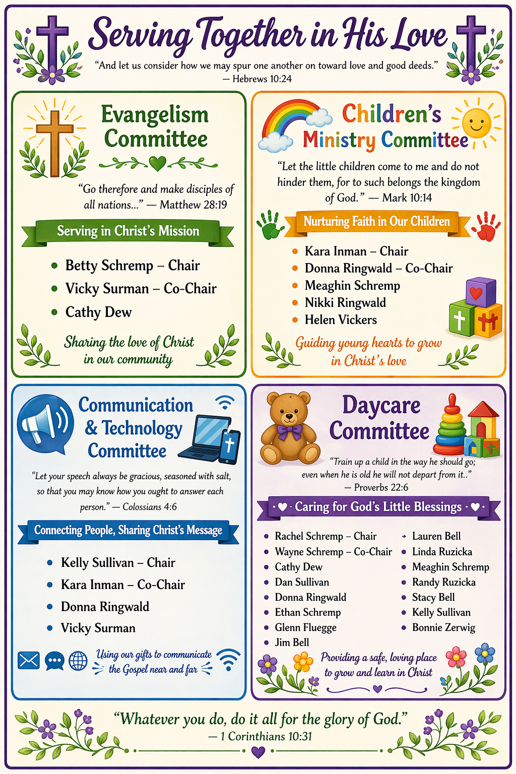
 A Special Gift

Acts 2:1-6, 14, 16-17a, 21 □ When the day of Pentecost arrived, they were all together in one place. And suddenly there came from heaven a sound like a mighty rushing wind, and it filled the entire house where they were sitting. And divided tongues as of fire appeared to them and rested on each one of them. And they were all filled with the Holy Spirit and began to speak in other tongues as the Spirit gave them utterance. Now there were dwelling in Jerusalem Jews, devout men from every nation under heaven. And at this sound, the multitude came together, and they were bewildered, because each one was hearing them speak in his own language. ... Peter ... addressed them: “Men of Judea and all who dwell in Jerusalem, ... this is what was uttered through the prophet Joel: ‘And in the last days it shall be, God declares, that I will pour out My Spirit on all flesh ... And it shall come to pass that everyone who calls upon the name of the Lord shall be saved.’”

When God gave the first Christians the gift of the Holy Spirit, they needed some way to recognize that the Holy Spirit was working through them—some kind of gift, some evidence of His presence. What should God choose?

He could’ve picked anything—healing or miracles or really persuasive preaching. But He picked none of those. Instead, He gave them the gift of speaking in languages they had never learned.

The gift of tongues means that other people can hear the Gospel, believe in Jesus, and be saved.
And that’s exactly what happened. The foreigners visiting Jerusalem for the holiday came together in the street, and they were shocked. All these people were speaking their own languages, even though they were clearly Galileans!

When God chose this one gift for Pentecost Day, that meant the Good News of Jesus got out into the world at top speed. Thousands of people heard that God had come into the world for their sakes, to live, to suffer, to die and to rise again—and that anyone who put their trust in Him would be forgiven and would live forever. And they responded. About 3,000 people believed and were baptized.

Going forward, sharing the Gospel wouldn’t be that easy. Missionaries would have to learn languages the hard way, most of the time. People would usually come to faith in smaller groups, or even one by one.

But for the birthday of the Christian church, God made sure we focused our attention on what matters to Him—reaching out with the Gospel to the people all around us who don’t yet know Jesus Christ. That is where God’s heart is, and that is where our hearts belong as well.

SEARCH-A-WORD PUZZLE
MOTHER’S DAY





