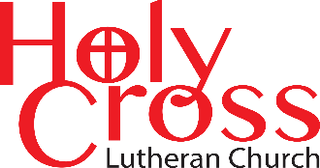
February 2026

We are transformed in Christ
to share the hope of eternal life.


CROSS-WORD

Newsletter



The Transfiguration of Our Lord
What is transfiguration to you?
Holy Cross Lutheran Church
The Lutheran Church—Missouri Synod
200 Market Street, Ste. Genevieve, MO.63670
Office Phone 573-883-5361
holycrossstegen@gmail.com
Website: holycrossstegen.org
Facebook: facebook.com/holycrossstegen
Needs for pastoral care in our area, call one of our Elders-
Rick Hutson 573-780-9390, Randy Ruzicka 314-210-4279
or Wayne Schremp 573-883-6060
Church Hours
Secretarial hours Wednesday/Thursday/Friday
11:30 AM to 3:30 PM
Connie Schwent Administrative Secretary 573-535-0084
Sunday’s church doors open at 8:00 AM service begins at 9:00 AM following with a Bible Study coffee and pastries generally served.
Tuesdays Bible study starting at 10:30 AM to 11:30 AM
From the Secretary’s desk.
Old man winter is upon us remember to check for cancellations of Sunday services and bible studies on our Facebook membership page or one of the following for future information.
Weather Communication
In the event that inclement winter weather is anticipated over a weekend and may affect our church service, please note the following notification procedures:
- A cancellation announcement will be posted on our official Facebook page (search “Holy Cross Lutheran Church—Ste. Genevieve”).
- Notices will also appear on local Ste. Genevieve radio station KBDZ and television stations KSDK Ste Gen TV 990/991.
- Channel 5 news
- Updates will be shared on our Facebook Membership page, “Friends of Holy Cross.”
- A text and phone call chain will be activated to inform members.
- You may also contact one of the Elders directly for specific cancellation details.
Decisions regarding service cancellations will be made by no later than 7:00 AM on Sunday mornings but may occur as early as 5:00 PM on Saturday evenings.
For those with Cable TV in Ste. Genevieve, sermons from previous Sundays can be viewed on Channel 990/991. Additionally, past sermons are available on YouTube and via our website at “holycrossstegen.org.”




– LCMS Stewardship Ministry: lcms.org/stewardship
LCMS Stewardship Ministry

Newsletter Article November 2025

Staying Out of the Ditches
Editor’s note: Monthly articles from LCMS Stewardship Ministry are hosted here on The Lutheran Witness site. Visit the “Ministry Features” page each month for additional stewardship content.
A ditch on either side of the road is still a ditch. The one on the left side of the road will damage your car as much as the one on the right side. Entering either ditch will prevent you from getting to your destination on time, if at all. Ditches come in all shapes and sizes, but there is one constant with them: you do not want to drive into them.
This reality of ditches is true on the wide, flat, fresh concrete of an interstate highway. Well-maintained medians and ditches are full of peril. It is also true of a winding asphalt or gravel backroad in the country. These might be even more dangerous because they do not readily reveal their depth, content and danger. It is true: a ditch on ANY road is still a ditch.

The Ditch of anxiety
This is especially true of the ditches on either side of the narrow road of faithful stewardship. On one side of the road is the hazardous ditch that is known as anxiety. This is prevalent in congregations, leadership groups and even among individual stewards. The ditch of anxiety is filled with the fear that if the steward is faithful and is sacrificially living out their identity as a steward, they just might run out of what they need to support this body and life.
This idolatrous anxiety causes the steward to cling so tightly to what they have at the expense of faithful stewardship of the Gospel. This hampers faithful service within the congregation and inhibits faithful outreach into the community in which the congregation has been planted. It creates the wreckage of fear of lack, fear of missing out and fear of being less than we want to be. This ditch crashes faithful stewardship.

The ditch of apathy
The ditch on the other side of the road is not any better. That one goes by the name of apathy. This is an ever-present issue in legacy congregations. The stewards in these congregations look around at their familiar settings and they do not like what they see. The pews that used to be full are mostly empty. The filled parking lots of holiday services stand vacant. The familiar faces grow older and grayer. The children that used to fill Sunday school rooms and parts in the Christmas programs went off to college, only never to return.
Neighborhoods have changed demographics, socioeconomics and ethnicity. Rural and city congregations emptied as populations moved to greener pastures. In the face of all this, the steward feels helpless, helpless, and hopeless. The fear is that the remnant is powerless to make any changes, and this leads to a general feeling of apathy.
The apathetic steward sighs, shrugs and goes careening into the dangerous ditch of apathy that leaves the carnage of thinking that no serving, no caring and no generosity will ever be effective. This paralyzes the mission of the church, the ministry of the congregation and the work of the individual steward. This ditch crashes faithful stewardship.

Staying on the road
There is only one option. Jesus, the One who is the Way, the Truth and the Life, is the factor that keeps us on the narrow way. When the Holy Spirit is working through the Word of God taught in its truth and purity and the Holy Sacraments administered in accordance with their institution by Christ, the steward is guided along the winding road of life in this world with a clear vision of eternity in mind. The presence of Jesus in the lives of stewards breeds a faithfulness that keeps the steward out of both ditches, which can and will leave lives in wreckage.
Daily devotions and the weekly Divine Service are where the Spirit does His work connecting the steward to Jesus. In fact, the faithful steward finds that the most important thing worth stewarding is the Gospel. The daily management of all of life and life’s resources serve the purpose of supporting and expanding the work of the Gospel in our families, our communities and our world. Here is where stewardship and mission go hand in hand.
The key to keeping stewards and congregations out of either ditch is keeping the stewards in Christ. Faithful proclamation of Jesus Christ is essential. Deepening connections to the Holy Scriptures are necessary. Weekly reception of the Lord’s Supper is a grand idea as well. If we are stewards of the Gospel of Jesus Christ, which we are by virtue of our baptism, then the steward can never get enough Jesus in Word and Sacrament. Faithful proclamation and reception of the Way, the Truth and the Life is the only way to keep stewards and their congregations out of the two equally devastating ditches on either side of the narrow way.

Called out of the ditches
The road has been paved by the Word of Jesus at the cross and empty tomb. The faithful steward receives this treasure with joy knowing that it is FOR THEM, but not about them. This Gospel then moves them to be even more faithful with what the Lord entrusts to them for the sake of others. A ditch on either side of the narrow way is still a ditch. But Jesus calls us out of it. For His glory and the benefit of our neighbor!

Lenten services are coming up soon
Holy Cross will be holding services
For information about other locations, you can contact the church or look for updates in upcoming
newsletters or bulletins
regarding weekly Lenten services in our community.

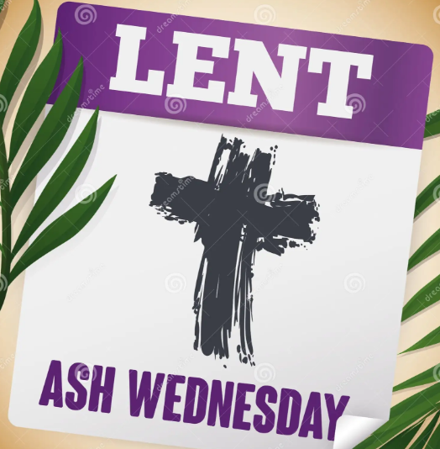

February 18th starting at 6:30 PM

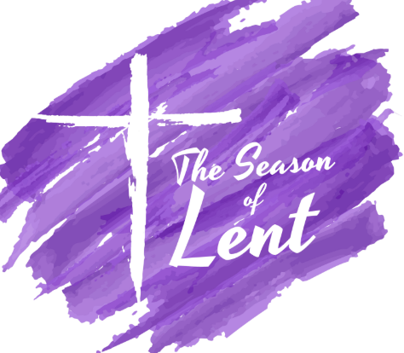

Palm Sunday March 29th 9:00 AM

Mid-Week Services –

Maundy Holy Thursday at 6:30 PM

Good Friday at 6:30 PM

Easter Sunday at 9:00

SEARCH-A-WORD PUZZLE





