DECEMBER 2 0 2 5
SUNDAY | MONDAY | TUESDAY | WEDNESDAY | THURSDAY | FRIDAY | SATURDAY
Hope your stocking is filled with joy and goodwill this year!!  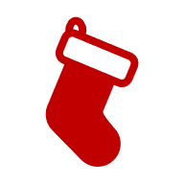 | 1 | 2  10:30 AM  Bible Class | 3 | 4 | 5  Drop off cookies for Festival | 6  Ste. Genevieve Holiday Festival
7 The Second Sunday in Advent  \  9:00 AM Worship Service (HC)  Bible Class after the service  Pastor Jarold Rux  Ste. Genevieve Holiday Festival | 8 | 9 10:30 AM  Bible Class  Ron and Linda Bollinger Anniversary | 10 | 11 | 12 | 13  9:00 AM Church Council Meeting
14 The Third Sunday in Advent  9:00 AM Worship Service (HC)  Bible Class after the service  Pastor Mark Hofferber  December Voters’ Meeting  after the service | 15 | 16  10:00 AM  Prepare church for tour | 17  10:30 AM- to 12:30pm Poinsettias set up | 18  Christmas Country Church Tour  1PM – 8 PM | 19  Jeff and Paula Boland Anniversary | 20  Bill and Vicky Surman Anniversary
21 The Fourth Sunday in Advent  9:00 AM Worship Service (HC)  Bible Class after the service  Pastor Peter Kirby | 22 | 23 | 24  6:00 PM  Christmas Eve Service  Peyton Holland | 25  Christmas Day | 26 | 27
28 First Sunday after Christmas  9:00 AM Worship Service (HC)  Bible Class after the service | 29 | 30 | 31  New Year’s Eve 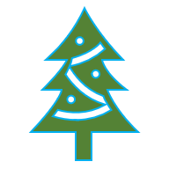

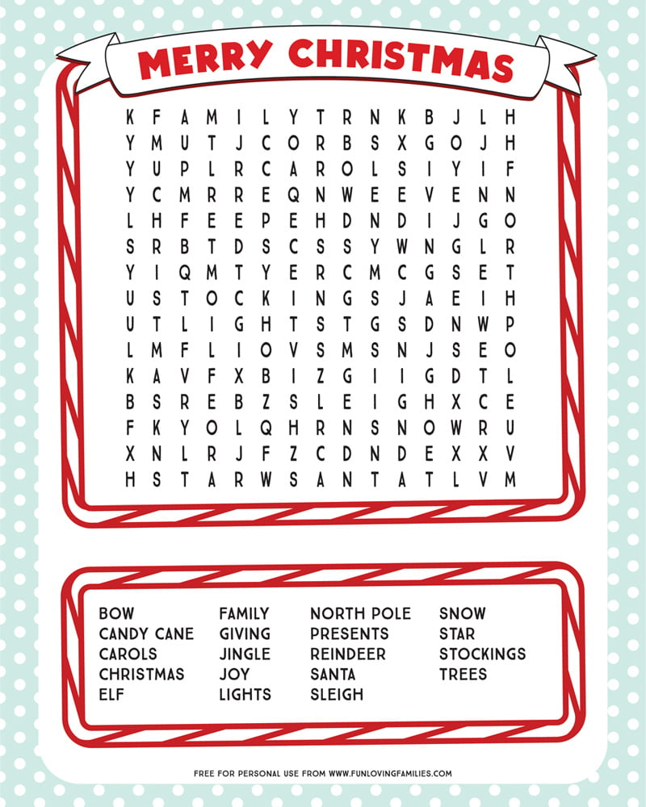

Holy Cross Members
Celebrating Birthdays
in December

December 15 Nevaeh Schlueter
December 16 Nick Krege
December 20 Helen Vickers
December 23 Kara Inman

A blessed birthday to you!

And Wedding Anniversaries

Ron & Linda Bollinger – December 9
Jeff & Paula Boland – December 19
Bill & Vicky Surman – December 20

     

