
WE ARE TRANSFORMED IN CHRIST
to Share the Hope of Eternal Life.
Nineteenth Sunday after Pentecost
October 19, 2025

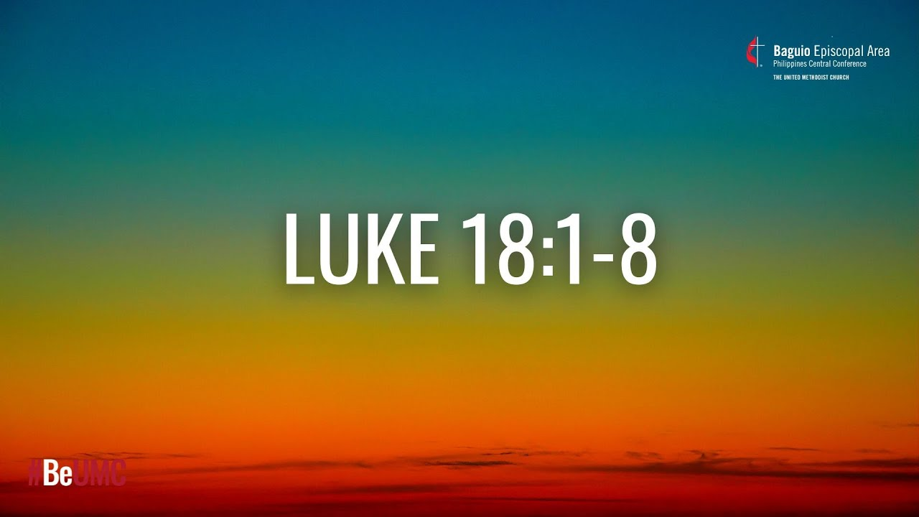

Holy Cross Lutheran Church
The Lutheran Church—Missouri Synod

200 Market Street, Ste. Genevieve, MO.63670
Office Phone 573-883-5361 holycrossstegen@gmail.com
Website: holycrossstegen.org
Facebook: facebook.com/holycrossstegen
Needs for pastoral care in our area, call one of our Elders-
Rick Hutson 573-780-9390,
Randy Ruzicka 314-210-4279 or Wayne Schremp 573-883-6060

THE ORDER OF SERVICE

The ringing of the bells starts at 9 a.m. Pastor/Seminarian prepares for a long set of bell tones before walking up to altar.

October 26th is Reformation Day, the color is Red for next Sunday if you are attending could you wear something with this color, it is a tradition, thank you in advance.

Words written in Bold generally signify congregation response.

The Greeting

This is the day that the Lord has made.
Let us rejoice and be glad in it.

We are transformed in Christ
To share the hope of eternal Life.

Welcome, let us stand and share the sign of peace and conversation.

Sit

578 Thy Strong Word
Text: Martin H. Franzmann, 1907–76

Stand

The sign of the cross may be made by all in remembrance of their Baptism.

P In the name of the Father and of the T Son and of the Holy Spirit.
C Amen.

P Our help is in the name of the Lord,
C who made heaven and earth.

P If You, O Lord, kept a record of sins, O Lord, who could stand?
C But with You there is forgiveness; therefore, You are feared.

P Since we are gathered to hear God’s Word, call upon Him in prayer and praise, let us first consider our unworthiness and confess before God and one another that we have sinned in thought, word, and deed, and that we cannot free ourselves from our sinful condition. Together as His people let us take refuge in the infinite mercy of God, our heavenly Father, seeking His grace for the sake of Christ, and saying: God, be merciful to me, a sinner.

C Almighty God, have mercy upon us, forgive us our sins, and lead us to everlasting life. Amen.

P Almighty God, merciful Father, in Holy Baptism You declared us to be Your children and gathered us into Your one, holy Church, in which You daily and richly forgive us our sins and grant us new life through Your Spirit. Be in our midst, enliven our faith, and graciously receive our prayer and praise; through Your Son, Jesus Christ, our Lord.
C Amen.

Service of the Word

Introit Psalm 74:18–19, 21, 20a, 22a; antiphon: v. 2a
Remember your congregation, which you have purchased of old,
which you have redeemed to be the tribe of your heritage!
Remember this, O Lord, how the enemy scoffs,
and a foolish people reviles your name.
Do not deliver the soul of your dove to the wild beasts;
do not forget the life of your poor forever.
Let not the downtrodden turn back in shame;
let the poor and needy praise your name.
Have regard for the covenant;
arise, O God, defend your cause.
Glory be to the Father and to the Son
and to the Holy Spirit;
as it was in the beginning,
is now, and will be forever. Amen.
Remember your congregation, which you have purchased of old,
which you have redeemed to be the tribe of your heritage!

Kyrie LSB 204
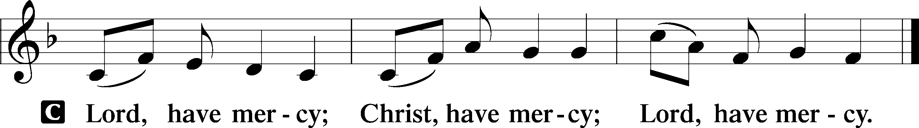

Gloria in Excelsis (intro) LSB 204
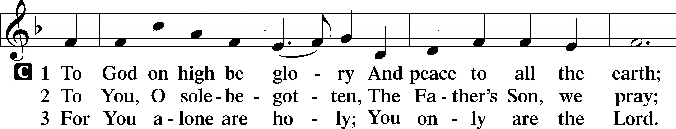
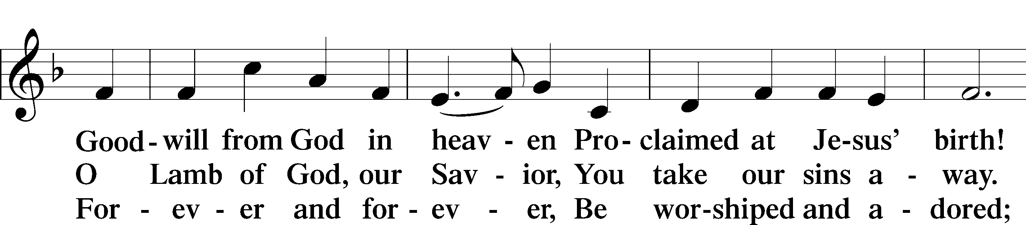
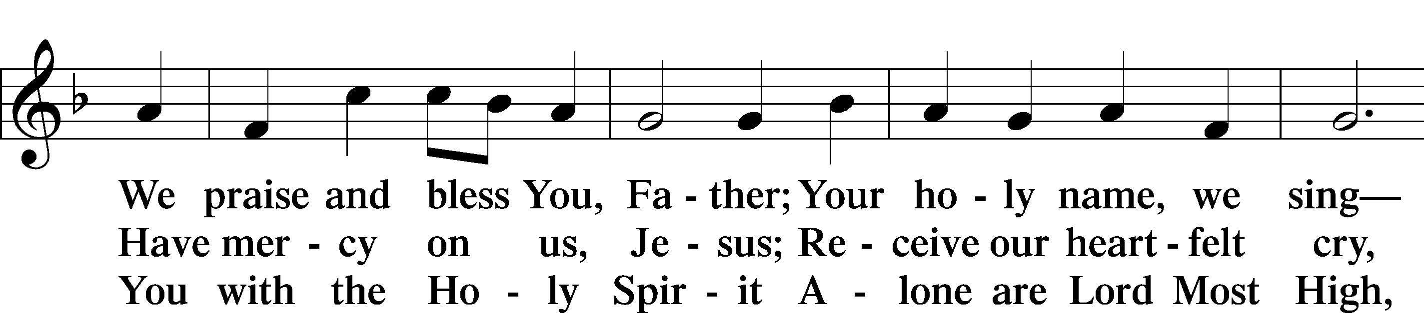
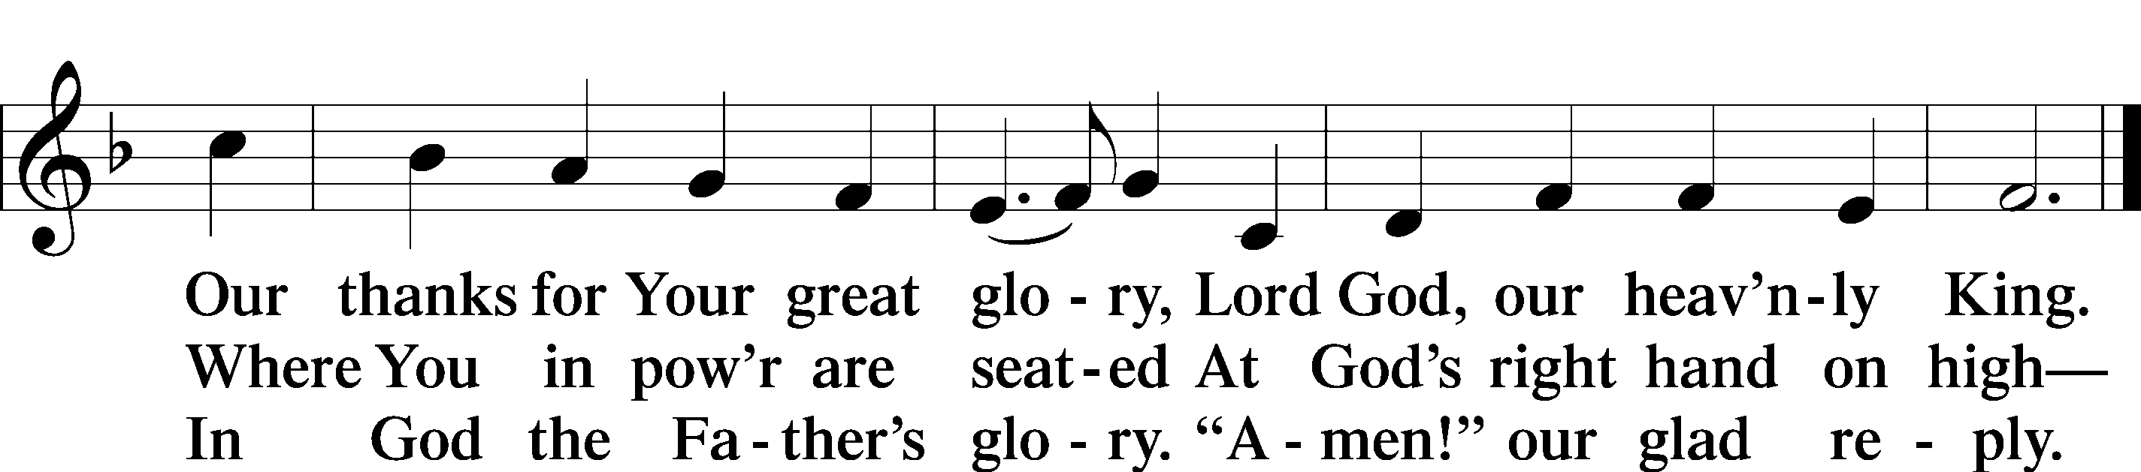
Text: Stephen P. Starke

Salutation and Collect of the Day
P The Lord be with you.
C And also with you.

P Let us pray.
O Lord, almighty and everlasting God, You have commanded us to pray and have promised to hear us. Mercifully grant that Your Holy Spirit may direct and govern our hearts in all things that we may persevere with steadfast faith in the confession of Your name; through Jesus Christ, Your Son, our Lord, who lives and reigns with You and the Holy Spirit, one God, now and forever.

C Amen.

Sit

Old Testament Reading Genesis 32:22–30
22The same night [Jacob] arose and took his two wives, his two female servants, and his eleven children, and crossed the ford of the Jabbok. 23He took them and sent them across the stream, and everything else that he had. 24And Jacob was left alone. And a man wrestled with him until the breaking of the day. 25When the man saw that he did not prevail against Jacob, he touched his hip socket, and Jacob’s hip was put out of joint as he wrestled with him. 26Then he said, “Let me go, for the day has broken.” But Jacob said, “I will not let you go unless you bless me.” 27And he said to him, “What is your name?” And he said, “Jacob.” 28Then he said, “Your name shall no longer be called Jacob, but Israel, for you have striven with God and with men, and have prevailed.” 29Then Jacob asked him, “Please tell me your name.” But he said, “Why is it that you ask my name?” And there he blessed him. 30So Jacob called the name of the place Peniel, saying, “For I have seen God face to face, and yet my life has been delivered.”

A This is the Word of the Lord.
C Thanks be to God.

Psalm Psalm 121; antiphon: vv. 1–2
1I lift up my eyes to the hills.
From where does my help come?
2My help comes from the Lord,
who made heaven and earth.
3He will not let your foot be moved;
he who keeps you will not slumber.
4Behold, he who keeps Israel
will neither slumber nor sleep.
5The Lord is your keeper;
the Lord is your shade on your right hand.
6The sun shall not strike you by day,
nor the moon by night.
7The Lord will keep you from all evil;
he will keep your life.
8The Lord will keep
your going out and your coming in
from this time forth and forevermore.

Epistle 2 Timothy 3:14—4:5
14As for you, continue in what you have learned and have firmly believed, knowing from whom you learned it 15and how from childhood you have been acquainted with the sacred writings, which are able to make you wise for salvation through faith in Christ Jesus. 16All Scripture is breathed out by God and profitable for teaching, for reproof, for correction, and for training in righteousness, 17that the man of God may be competent, equipped for every good work.
1I charge you in the presence of God and of Christ Jesus, who is to judge the living and the dead, and by his appearing and his kingdom: 2preach the word; be ready in season and out of season; reprove, rebuke, and exhort, with complete patience and teaching. 3For the time is coming when people will not endure sound teaching, but having itching ears they will accumulate for themselves teachers to suit their own passions, 4and will turn away from listening to the truth and wander off into myths. 5As for you, always be sober-minded, endure suffering, do the work of an evangelist, fulfill your ministry.

A This is the Word of the Lord.
C Thanks be to God.

Stand

Alleluia and Verse (intro)

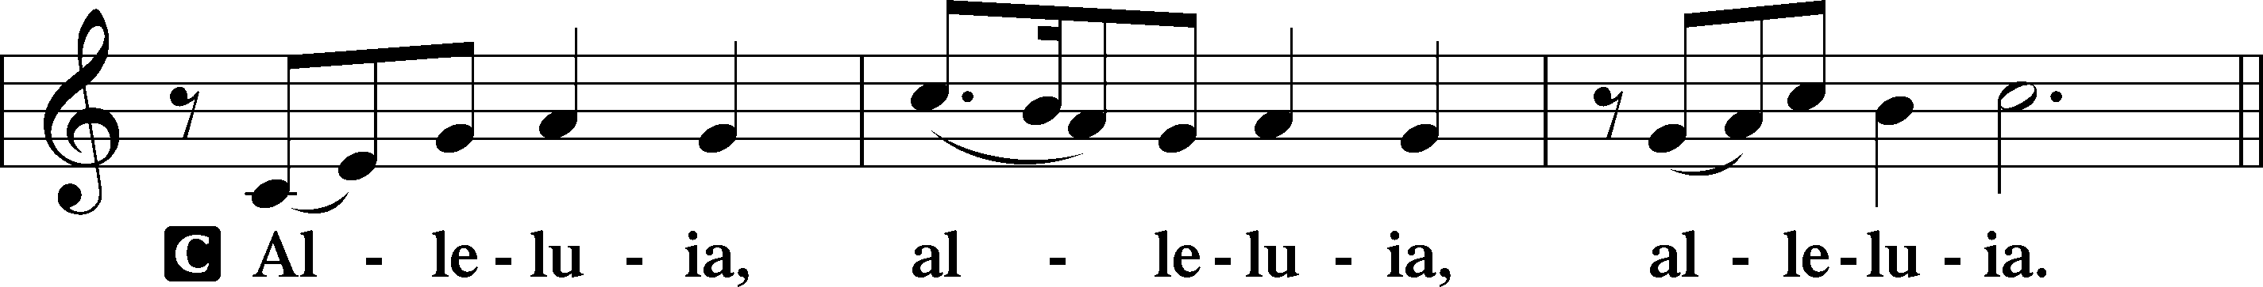

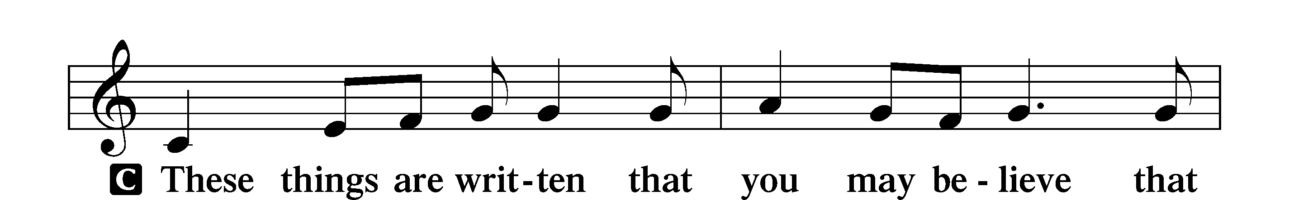
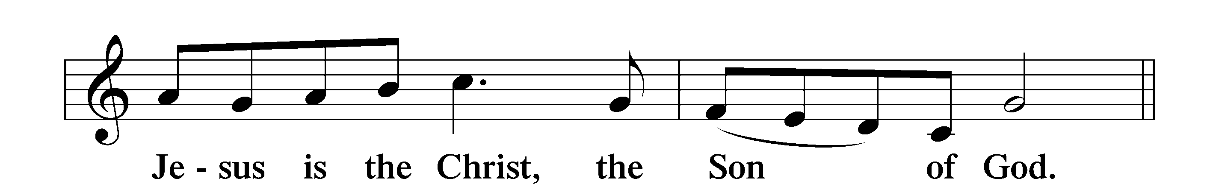

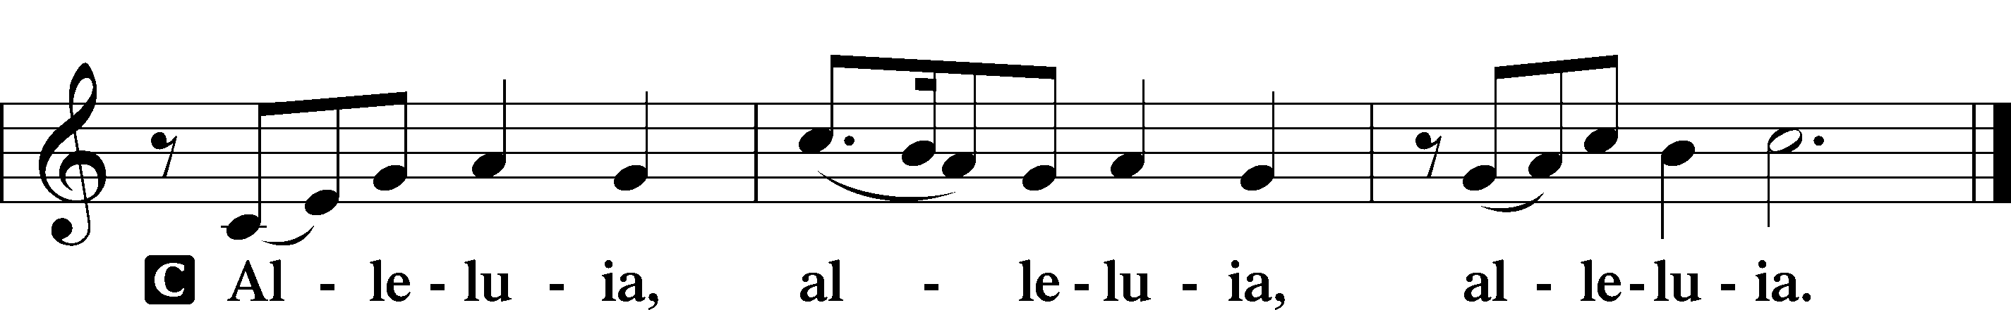

Holy Gospel Luke 18:1–8
P The Holy Gospel according to St. Luke, the eighteenth chapter.
C Glory to You, O Lord.

1[Jesus] told them a parable to the effect that they ought always to pray and not lose heart. 2He said, “In a certain city there was a judge who neither feared God nor respected man. 3And there was a widow in that city who kept coming to him and saying, ‘Give me justice against my adversary.’ 4For a while he refused, but afterward he said to himself, ‘Though I neither fear God nor respect man, 5yet because this widow keeps bothering me, I will give her justice, so that she will not beat me down by her continual coming.’” 6And the Lord said, “Hear what the unrighteous judge says. 7And will not God give justice to his elect, who cry to him day and night? Will he delay long over them? 8I tell you, he will give justice to them speedily. Nevertheless, when the Son of Man comes, will he find faith on earth?”

P This is the Gospel of the Lord.
C Praise to You, O Christ.

Apostles’ Creed
P God has made us His people through our Baptism into Christ. Living together in trust and hope, we confess our faith.
C I believe in God, the Father Almighty,
maker of heaven and earth.

And in Jesus Christ, His only Son, our Lord,
who was conceived by the Holy Spirit,
born of the virgin Mary,
suffered under Pontius Pilate,
was crucified, died and was buried.
He descended into hell.
The third day He rose again from the dead.
He ascended into heaven
and sits at the right hand of God the Father Almighty.
From thence He will come to judge the living and the dead.

I believe in the Holy Spirit,
the holy Christian Church,
the communion of saints,
the forgiveness of sins,
the resurrection of the body,
and the life T everlasting. Amen.

Sit

734 I Trust, O Lord, Your Holy Name
Text: Adam Reusner, 1496–c. 1575
Text: Public domain

Sermon – Be Resilient Seminarian: Jim Wiencke

For today's prayer requests, please write them on the attendance card provided during the service. Once completed, fold the card and either hand it to an usher or place it in the offertory plate. The Pastor or Seminarian will include these requests during the Prayers of the Church.

We honor the Lord with our tithes and our gifts. Please Stand as the offering is brought forward and sing

Stand
Three ways to give:

1) offering plate—cash or check.
2) online at holycrossstegen.org Click the “Give” icon.
3) by mail.

Stand

956 Create in Me(intro)
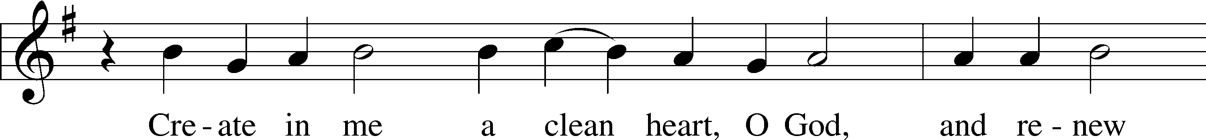
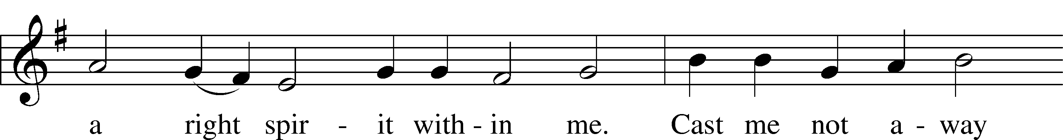
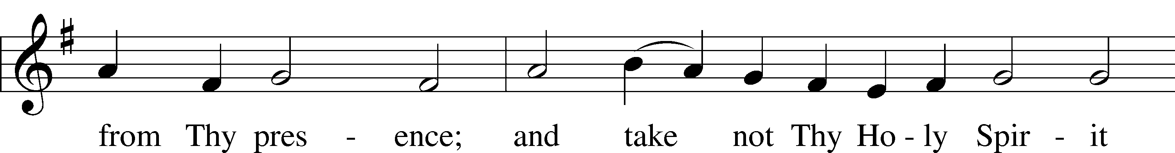
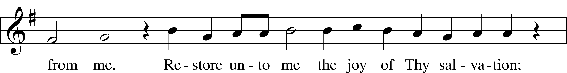
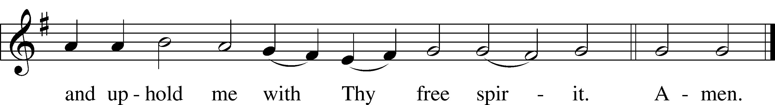
Text: Psalm 51:10–12
Tune: Johann Georg Winer, 1583–1651, adapt.
Text and tune: Public domain

Prayer of the Church

Nineteenth Sunday after Pentecost October 19, 2025

Let us pray for the whole Church of God in Christ Jesus and for all people according to their needs.

Lord God of Israel, we give You thanks for Jesus Christ, David’s Son and Lord, on whom hangs all the Law and the Prophets. Reconciled to You by His righteousness, lead us as disciples to make a godly beginning in the love of You and of our neighbors. Lord, in Your mercy, hear our prayer.

O Lord, bless our congregations. Enrich young and old with the testimony about Christ. Confirm them with every spiritual gift, and sustain them in this fellowship to the end, guiltless in the day of the revelation of our Lord Jesus Christ. Lord, in Your mercy, hear our prayer.

Receive, O Lord, our thanks and praise for our sister churches who share with us in the Word and Sacraments of Christ. Enrich them by Your grace and prepare them for His coming, that we may all be found blameless in His sight. Lord, in Your mercy, hear our prayer.

Heavenly Father, Your Son is Bridegroom and Lord, faithful over Your house, the Church. Raise up the sons of our congregations to follow Your Word, and bless their families with godly lives. Lord, in Your mercy, hear our prayer.

Almighty God, graciously uphold our republic with its lawmakers and executives. By their actions, let the common good be served. Bring their justice into accord with Your good order and command. Lord, in Your mercy, hear our prayer.

Gracious Lord, Your Son is the Son of David and yet Lord of all. Send Your Spirit of healing to [_____________ and] all who are ill or injured or troubled among us. Lord, in Your mercy, hear our prayer.

Merciful God, You call us to pray for the peace of Jerusalem, Your Holy Christian Church. As we come to receive the peace of the Lord in this Sacrament, let this true peace be with us always. Lord, in Your mercy, hear our prayer.

O Lord, heavenly Father, we gratefully remember the sufferings and death of Your dear Son, Jesus Christ, for our salvation. Rejoicing in His victorious resurrection from the dead, we draw strength from His ascension before You, where He ever stands for us as our own High Priest. Gather us together from the ends of the earth to celebrate with all the faithful the marriage feast of the Lamb in His kingdom, which has no end. Graciously receive our prayers, deliver and preserve us, for to You alone we give all glory, honor and worship, Father, Son and Holy Spirit, one God, now and forever. Amen.

Lord’s Prayer
C Our Father who art in heaven,
hallowed be Thy name,
Thy kingdom come,
Thy will be done on earth
as it is in heaven;
give us this day our daily bread;
and forgive us our trespasses
as we forgive those
who trespass against us;
and lead us not into temptation,
but deliver us from evil.
For Thine is the kingdom
and the power and the glory
forever and ever. Amen.

Pax Domini
P The peace of the Lord be with you always.
C Amen.

Nunc Dimittis(intro) LSB 211
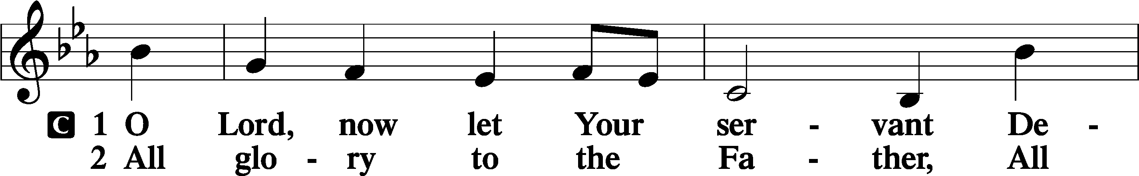
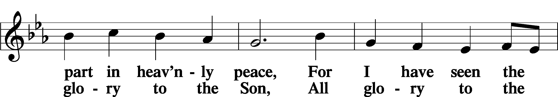
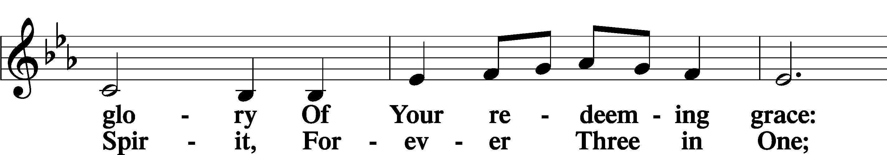
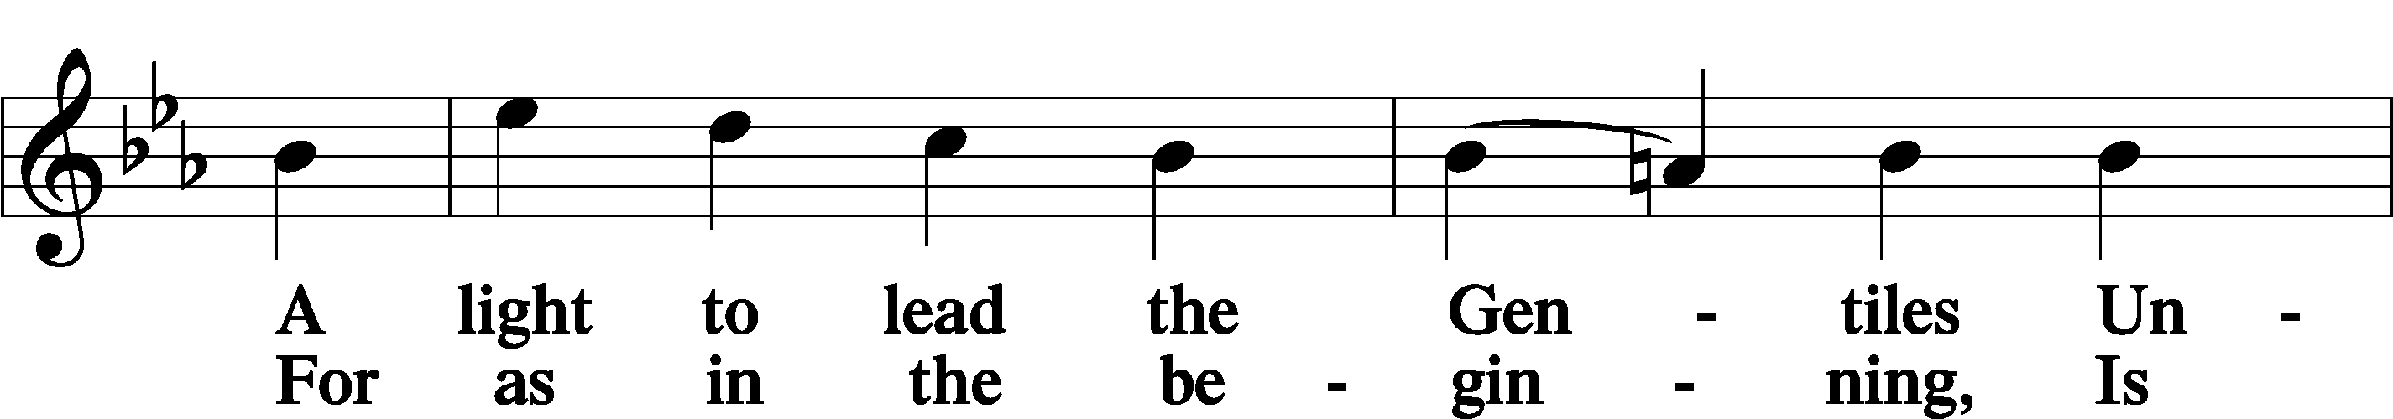
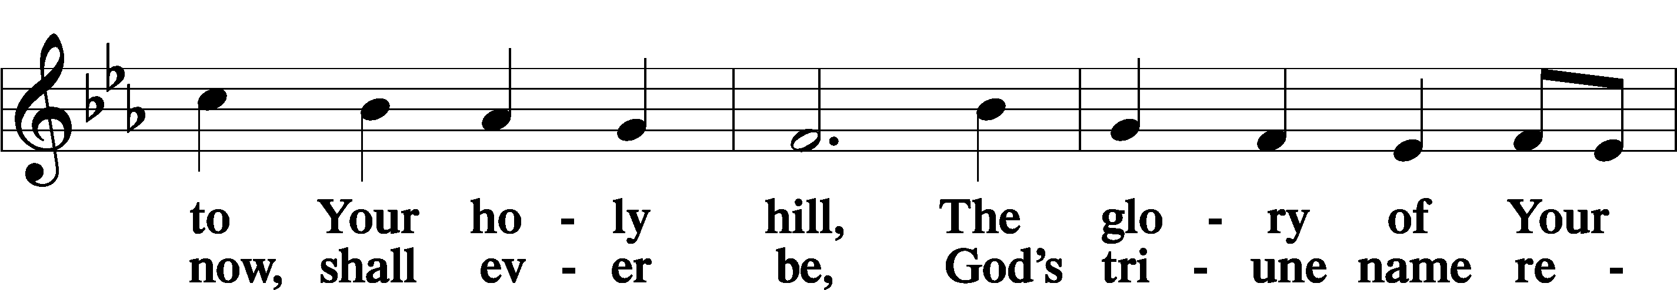
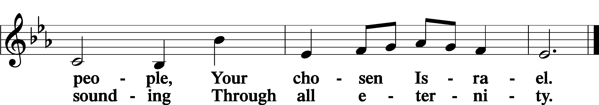

Benedicamus LSB 212
A Let us bless the Lord.
C Thanks be to God.

Benediction
P The Lord bless you and keep you.
The Lord make His face shine on you and be gracious to you.
The Lord look upon you with favor and T give you peace.
C Amen.

Sit

924 Lord, Dismiss Us with Your Blessing

Acknowledgments
Divine Service, Setting Four from Lutheran Service Book
Unless otherwise indicated, Scripture quotations are from the ESV® Bible (The Holy Bible, English Standard Version®), copyright © 2001 by Crossway, a publishing ministry of Good News Publishers. Used by permission. All rights reserved.
Created by Lutheran Service Builder © 2025 Concordia Publishing House.



OCTOBER/NOVEMBER EVENTS

The fresh flower arrangement on the altar,
given by John and Bonnie Zerwig this Sunday.
The occasion, in Remembrance of Elmer and Alice Wichern Anniversary.

Please note today is the voters meeting immediately following the service everyone is welcome to join.

Seeking volunteers to assist Helen Vickers with her moving into Audubon Estates #24 apartment in Saint Genevieve, Mo. October the 25th, 2025 assisting is primarily needed for moving boxes if you own a dolly or similar equipment please bring it your support is greatly appreciated, not sure what time we are starting should know this by October the 20th just call the office.

Reformation Jubilee at Immanuel Lutheran Church Festus, a collaborative worship service on October 25, 2025, at 3:00 PM following with a dinner at 5:00 PM
- They need help on this day if you would like to volunteer, I'm sure they would appreciate it.
- Ushers, Greeters, Security, Food Providers and food servers will have more details at later date.
There are 4 lists to help Holy Cross. “1st” if you would like to make a purchase of $25 for a fresh flower arrangement to be put on the altar for Sundays. “2nd” list is to help watering flowering plants in the potters outside.”3rd”is help with volunteer jobs during the week or the month from running camera for live stream to cleaning or reading during the Sunday service,”4” calendar on the back of the kitchen door is to sign up for picking up fresh flower bouquets at Country Mart for Sunday service. All sign-up sheets are in back of church and in the Narthex/Kitchen door.

WEEKLY CALENDAR/UPDATES
Vacancy pastoral hours upon request
Secretarial hours Wednesday/Thursday/Friday 11:30 AM to 3:30 PM
Sunday’s church doors open at 8:00 AM service begins at 9:00 AM following with a Bible Study coffee and pastries generally served.
Tuesdays Bible study starting at 10:30 AM to 11:30

SERVING TODAY

Seminarian Jim Wiencke
Scripture Reader: Laura Pruneau-Fallert
Ushers: Wayne Schremp & Rick Hutson
Communion Servicer: Randy Ruzicka
Concordia Organist, IPad

Up-coming October 26,2025
Pastor: Mark Hofferber
Scripture Readers: Vickie Eisenbeis
Ushers: Wayne Schremp & Rick Hutson
Communion Servicer: Randy Ruzicka
Concordia Organist, IPad

Sunday Church Attendance | Attendance
First Week | 39
Second Week | 39
Third Week
Fourth Week
Fifth Week

Your Financial Support of Your Church | 10/12/25 | Year-to-Date
Weekly Budget Requirement | $2,777.00 | $113,857.00
Actual Offerings⎯including online offerings (budget) | $2,600.00 | $95,066.35
Ahead/Behind Budget Requirement | -$177.00 | -$18,790.65
% Ahead/Behind | -6.4% | -16.5%

In Our Prayers This Week and Celebrations
Throughout the week, please keep these people in your daily prayers. As a model for prayer, consider going through the A.C.T.S. of prayer. Adoration: praising God for who He is. Confession: confessing your sins to God, especially those that weigh on your heart. Thanksgiving: thanking God for specific blessings. Supplication: asking God for help.
For those who are homebound Barb Jones, Sharon Estes, Doug Arnold, Doris Bayuk, Nick Krege, Pansy Meyer.

For healing and continued recovery Bill Staffen (Bonnie Keir’s brother, cancer), Dustin Hutson (recovering from a brain bleed), Pastor Jim Kirk (treatment for myeloma), Carol Steiger-Rudoff hoping for good results of cancer surgery (Connie Schwent’s Sister In-law), Laura Pruneau Fallert (Cancer treatment). John George Jr. (Debbie George's son) has been diagnosed with cancer and will be seeking a 2nd medical opinion regarding the next steps in treatment. Caryl Phillips, she broke her hip, needs surgery and recovery. Please also pray for Wayne Phillips, he is in Saint Genevieve Memorial Hospital. Wayne suffered a fall overnight and has fractured his pelvis. He is being kept for more testing to ensure there aren’t any additional needs.

For those celebrating birthdays in October Eva May Rolfe’s (Oct. 03), Stacy Bell’s (Oct. 06), Timothy Inman’s (Oct. 07), Ethan Schremp’s (Oct. 08) James Bell’s (Oct. 17), Cindy Hutson’s (Oct. 28), Victoria Perschbacher’s (Oct. 30).

For those celebrating wedding anniversaries in October Nathan and Amanda Ringwald (Oct.01), Michael and Bonnie Keir’s (Oct. 27), Rick and Cindy Hutson’s (Oct. 28)

For Those Who Mourn

For local, state, and national elected officials that they uphold goodness and work humbly for those they serve.

For our community that more people believe the Gospel of Jesus Christ.

For our circuit congregations & missionaries

For our church family that we are transformed in Christ to share the hope of eternal life.

For all prayer requests not listed here but in our hearts.
If you would like a prayer request printed in the bulletin, contact the church office at 573-883-5361 or holycrossstegen@gmail.com by Wednesday noon. For other requests, write them on the attendance card at service, fold it, give it to an usher or place it on the offering plate. To remove your bulletin request please contact the church office or Connie’s cell 573 535 0084.

