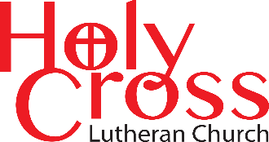
September 2025

We are transformed in Christ
to share the hope of eternal life.

CROSS-WORD NEWSLETTER
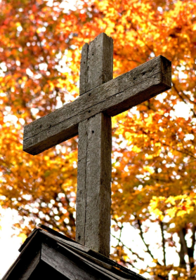


For everything,
there is a season
and time
for everything
under heaven.
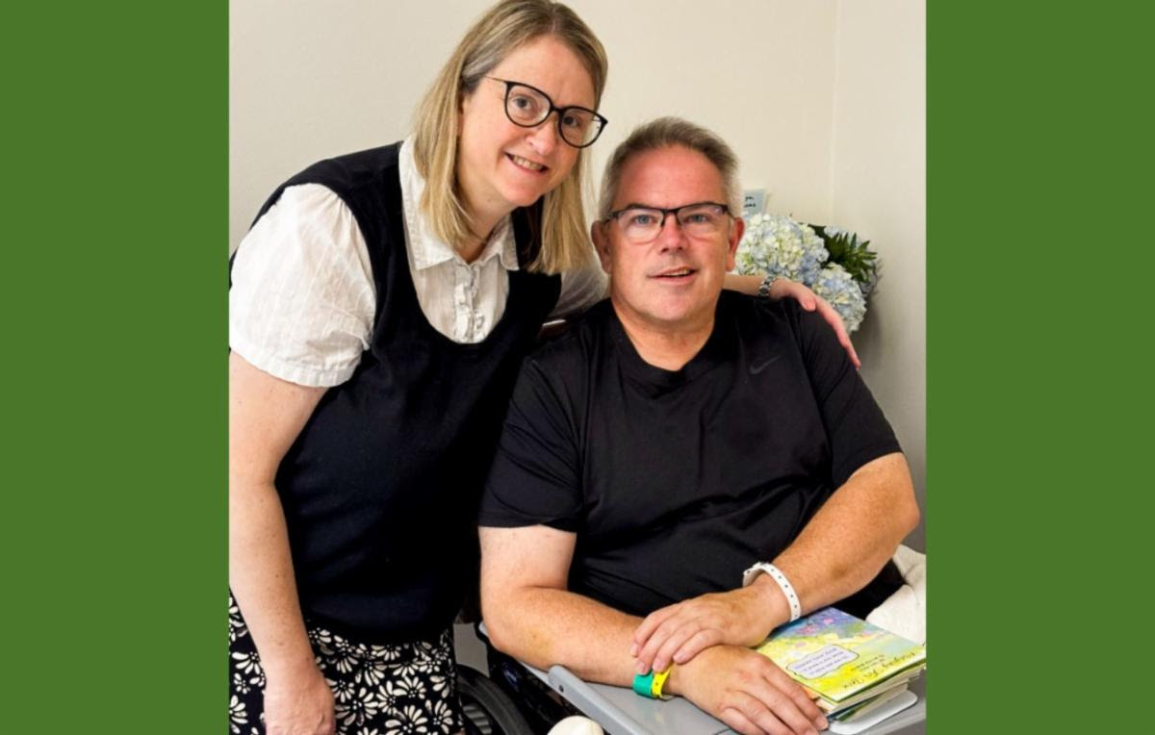

Dear friends in Christ,
We're writing today to provide a brief update on President Rev. R. Lee Hagan, along with a heart filled word of thanks on his behalf.
As many of you know, President Hagen experienced a stroke while attending the LCMS Youth Gathering in New Orleans in late July. Since then, he has remained in New Orleans for inpatient rehabilitation and continues to make steady progress. His care team remains optimistic, and plans are in place for him to transition back to Missouri later this month for outpatient therapy.
“We appreciate all of the prayers, notes, and expressions of support,” said President Lee and Jill Hagan. They also wanted to offer a glimpse of that encouragement in the above photo, which shows the two of them alongside some of their many cards sent during his time in New Orleans.
Please continue to lift the Hagen family up in prayer as he focuses on healing. Cards and notes may still be sent to the district office and will be forwarded to him
Missouri Senate-LCMS
660 Mason Ridge Center Drive., Suite 100
St. Louis, MO. 63141
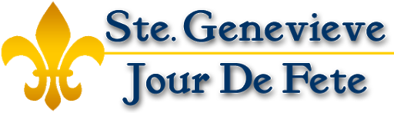

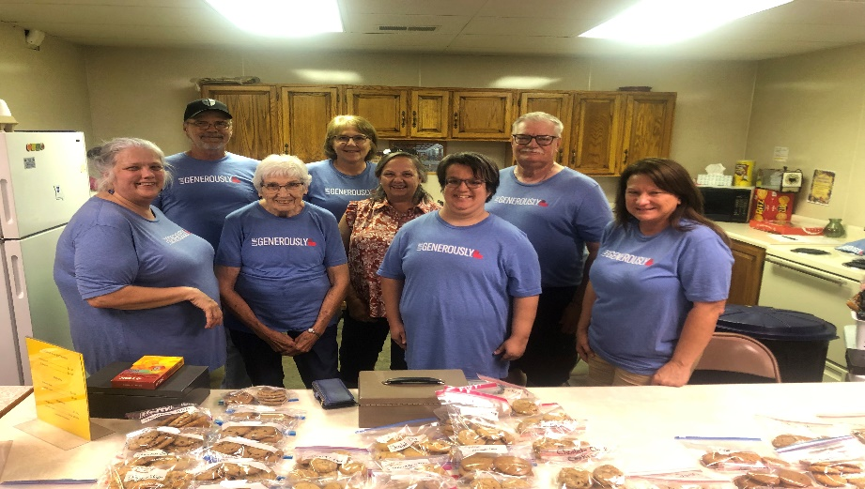
What an incredible couple of days we shared! The water stand and collectible/cookie sale for 2025 was a great success.

Thank you to all for your contributions, including prayers, collectibles, cookies/baked goods, crafts, popcorn, ice, water, cash donations, supply donations, time, hard work in hot weather and most of all, fellowship with each other and the community. Together, we made this event possible and raised $2,465.00 for evangelism/children's ministry. Each of you made a difference.

Please continue to keep the Evangelism and Children's Ministry committees in your thoughts and prayers as we go forward to share God's love.

Looking forward to next year!
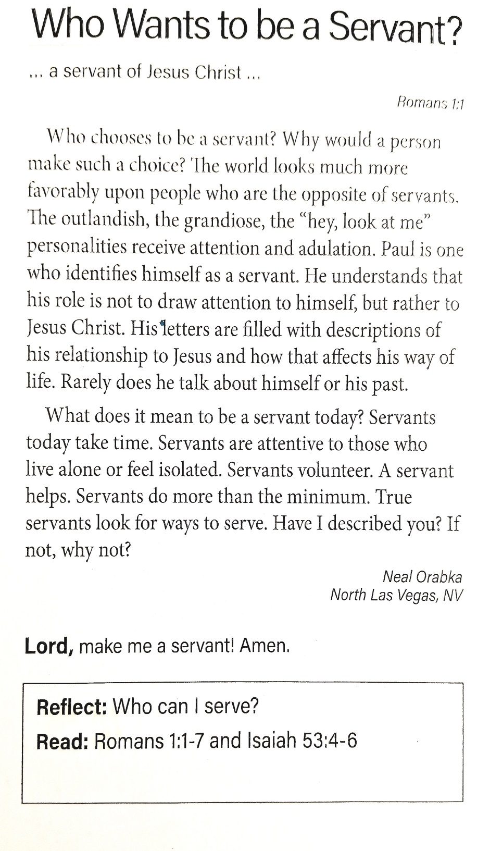Officers held at the present time until December 2025
Board of Elders 3-year terms Wayne Schremp-2-year, Rick Hutson-1year, Randy Ruzicka finish term in December.
Board of Trustees’ 3-year term. Rick Hutson - 1 year Jim Bell - finished term in December Dan Sullivan - finished term in December Glenn Fluegge - finished term in December.
Board of Evangelism 3-year term. Betty Schremp - 2 year, Vicky Surman – 2 year, Cathy Dew – 2 years.

Church Council 1-year term expires this year. President-Vicky Surman, Vice President-Paul Ringwald, Treasurer Tim Inman, Financial Secretary-Donna Ringwald, Recording Secretary-Connie Schwent.

“The list of current officers and council members stated above, additional copies are available. If anyone would like to serve as an officer or on the council, or know of anyone that would, please contact anyone on this list. All the boards are a three-year term, and NOT limited to only 3 members.” Please note that the Board of Evangelism covers several other Committees, such as Children's Ministry, Annual Picnic Coordinator, there are opportunities to assist with the Altar Guild and coordinate the meals we serve after funerals.

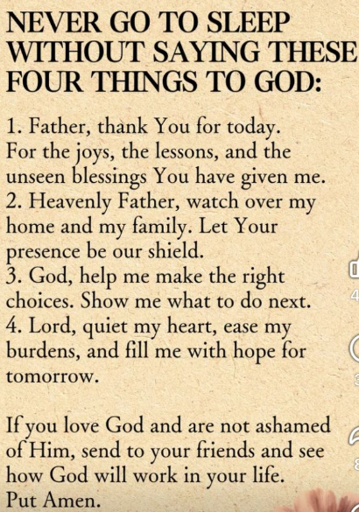

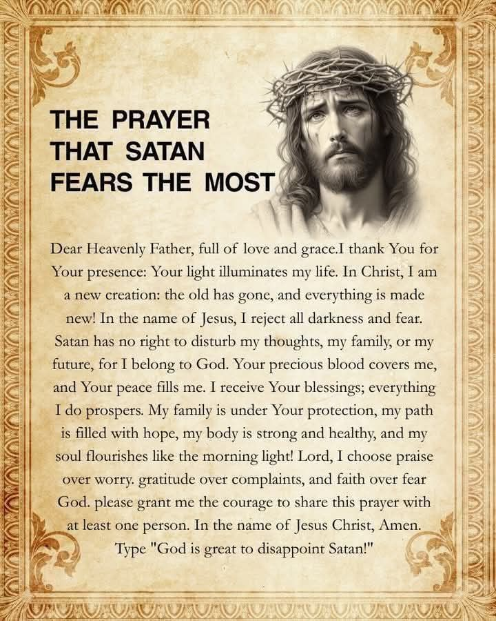

Flower Waterers are needed at church throughout the summer!

We need volunteers for help with watering the flowers outside at church daily throughout the FALL season too.


Please sign up on the sheet on the table in the back of the sanctuary.

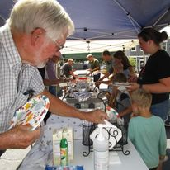
Upcoming Events

Church Picnic: September 28th?

We are looking for a team to head and organize our picnic this year.

Just not sure when.

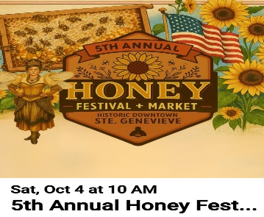 HoneyBee Festival

October 4th

Planning bake sale and crafts to help raise money for the Children’s Ministry. More details at later date in bulletins and Facebook.

Saxony Fall Festival

October 11th

Frohna Missouri

Reformation Jubilee

October 25th

Starting at 3:00 PM dinner will follow at 5:00 PM

Emmanuel Lutheran Church Festus

If interested they are looking for volunteers, ushers, greeters, security, food providers, more information will be in the bulletin and on the Holy Cross Narthex bulletin board.

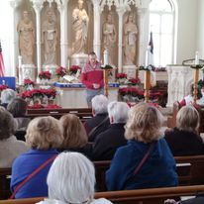

Christmas Festival

Ste. Genevieve:

December 6th and 7th

We will host concerts both days and serve cookies to our guests.

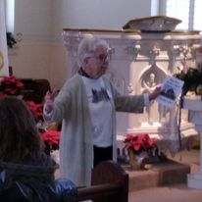

Christmas Country

Church Tour: December 18th

This year, Holy Cross will host tours on Thursday, December 18th, from 1:00p.m. to 8:00 p.m. Mark your calendar! Just need some of your great cookies for the visits.

SEARCH-A-WORD PUZZLE
