January 2026
Transformed in Christ to share
The Hope of eternal life


Newsletter
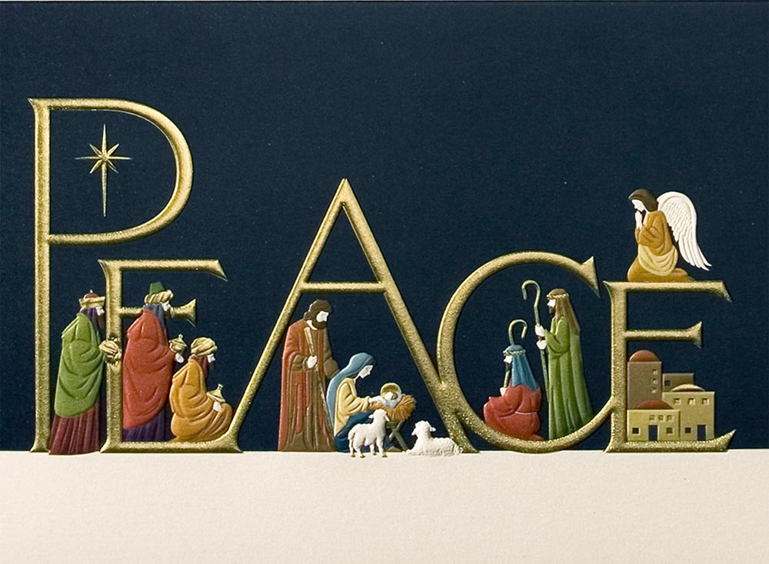
Holy Cross Lutheran Church

The Lutheran Church—Missouri Synod
200 Market Street, Ste. Genevieve, MO.63670
Office Phone 573-883-5361
holycrossstegen@gmail.com
Website: holycrossstegen.org
Facebook: facebook.com/holycrossstegen

Needs for pastoral care in our area, call one of our Elders-
Rick Hutson 573-780-9390,
Randy Ruzicka 314-210-4279 or Wayne Schremp 573-883-6060


From the Secretary’s desk.
Wally taught me a valuable lesson, thought that you might enjoy this story too.
Luke 2:7 “No Room in the Inn"

Wally was big for his age--seven years old. Everyone wondered what role the teacher would give him in the annual Christmas play. Especially considering the fact that he was also a slow learner. Perhaps he could pull the curtain.

To everyone's surprise the teacher gave Wally the role of the innkeeper. The boy of course was delighted. After all, all he had to learn was one line:

"There is no room in the inn." He had that down in no time.

Then came the night for the program. The parents took their places. Every seat in the auditorium was filled. The children entered singing "Oh come all ye faithful." The lights dimmed. A hush moved over the audience. The curtain opened on Scene One. Mary and Joseph entered the stage and walked up to the inn. "Please sir, my wife is not well. Could we have a room for the night?"

Wally was ready for his line. He had rehearsed it all night. He began, "there is", and he hesitated. He started over again. There is. . .and again his mind went completely blank. Everyone was embarrassed for him but poor Wally just didn't know what to do. Joseph thought he would improvise and started walking away toward the stable on stage left. Seeing him walking away Wally in desperation called out: "Look, there's plenty of room at my house, just come on home with me."

That seems a rather delightful twist on a familiar story. Over the years the characters in the Christmas story have become clearly defined for us. The issues all seem so clear cut. Herod was a villain and the wise men were heroes. The shepherds were heroes and the Innkeeper--well, the poor innkeeper has gone down as one of the heavies in the story. In our minds eye, we envision him as a crotchety old man with a night cap on his head sticking his head out a second story window and tersely shouting: Take the stable and leave me alone.

But perhaps the innkeeper has received bad press. Preachers over the centuries have had a field day with the poor fellow. But was it his fault that the inn was built with twelve rooms instead of thirteen? Was it his fault that Caesar Augustus had issued a decree that the entire world should be taxed? Was it his fault that Mary and Joseph were so late in arriving?

But you know something; this simple little statement about there being no room in the Inn becomes a symbol for Luke. As he writes his gospel it almost becomes a theme. Luke takes this one line, "There is no room in the inn," and shows us how this phrase was recurrent throughout Jesus' ministry. The question that Luke leaves for us is--will there ever be any room for him?

1. There was no room for Jesus in the economic world.
2. There was no room for Jesus in the legal realm.
3. There was no room for Jesus in the realm of the religious order.
4. There was no room for Jesus in the world of politics.
5. Let's look at us today--to you and to me. Do we have room for Christ in our lives?



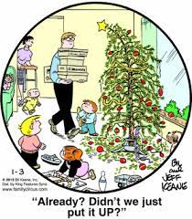

We are planning to take down Christmas decorations and distribute poinsettias on January 4, 2026, following the 9:00 AM service, weather permitting. If we are unable to complete the process, we will continue Saturday, January 3rd, at 8:30 AM.

Also, Pastor Rux is hosting an Epiphany party for Holy Cross after church service on January 4th, The event will have holiday punch nonalcoholic, snacks, nuts, dessert, and assorted appetizers. Since Epiphany is known as CHRISTmas of the Gentiles, Pastor will be bringing some holiday CDs to play. An informal church gathering to celebrate our Savior's birth.

SEARCH-A-WORD PUZZLE
GOD’S BEAUTIFUL CREATION
