
November 2025

Transformed in Christ
to share the hope of eternal life


CROSS-WORD
NEWSLETTER

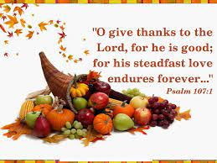

Holy Cross Lutheran Church
The Lutheran Church—Missouri Synod
200 Market Street, Ste. Genevieve, MO.63670
Office Phone 573-883-5361 holycrossstegen@gmail.com
Website: holycrossstegen.org
Facebook: facebook.com/holycrossstegen
Needs for pastoral care in our area, call one of our Elders-
Rick Hutson 573-780-9390,
Randy Ruzicka 314-210-4279 or Wayne Schremp 573-883-6060



Retraction from October 2025 Newsletter- President Rev. R Lee Hagen had the stroke not Kyle Castrens. Prayers and warm thoughts are still welcomed for his family.


Save the Date!

This year, our Thanksgiving service will be held on Wednesday, November 26, at 6:00 P.M.

Please join us for this special opportunity to thank God for the many blessings He has given to us!




CHURCH CHRISTMAS DECORATING

Church decorating will begin on Friday, November 28th with the installation of interior banners, followed by additional indoor and outdoor Christmas decorations starting at 8:30am on Saturday the 29th. Your participation and assistance are greatly appreciated.

STE. GENEVIEVE CHRISTMAS FESTIVAL


December 6th & 7th We will not take part in the parade, but we will host concerts on both days. We are asking members to donate cookies for us to share with our guests. Also needed: volunteers to meet and greet our guests, sign-up sheets will be added to the bulletin board in the Narthex soon.

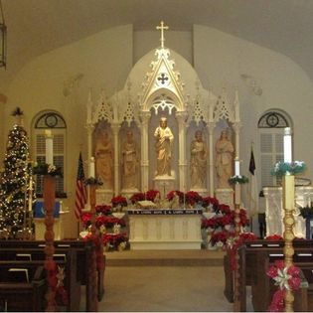
Christmas Country
Church Tour

December 18th (Thursday)
from 1 pm to 8 pm

December 16 (Tuesday): General cleaning and preparation for the church tour.
December 17 (Wednesday), 10:30 am to 12:30 pm: Displaying poinsettias on the church altar.
A sign-up sheet will be posted shortly for individuals interested in hosting and providing tours. Shifts will be available in four-hour increments each day.
Members are kindly requested to contribute homemade cookies, which have become a hallmark of our community. Cookies, along with Ste. Genevieve’s Oberle sausage and cheese, will be served in the Fellowship Room.
Participation in this event provides an opportunity to be actively involved during the holiday season.
All donations collected will support the future daycare program and Children’s Ministries.

PLEASE PLAN TO TAKE PART IN ALL OR JUST ONE OF THE UPCOMING EVENTS. It is an exciting time at Holy Cross, so join in to make it even better! Looking forward to seeing you!!

Participation in Operation Christmas Child
We are excited to announce that the Children’s Ministry Committee of Holy Cross Lutheran Church will be participating in Operation Christmas Child, a global outreach initiative organized by Samaritan’s Purse.
Operation Christmas Child is a wonderful opportunity for our congregation to share God’s love with children around the world. By filling shoeboxes with gifts, school supplies, and personal care items, we can help bring joy and hope to children in need this holiday season.
Members of our congregation are encouraged to get involved with the Children’s Ministry Committee and their families by collecting items, packing shoeboxes, and praying for the recipients. We will be hosting special packing sessions and providing more information about what to include in each box in the coming weeks, National Collection Week is November 17–24, 2025
Please join us as we work together to make a difference in the lives of children through this meaningful project. Thank you for helping us extend Christ’s love beyond our community!

Daylight Saving Time is coming to an end. It is time to turn our clocks BACK one hour on Saturday night, November 2nd. Be sure to set all your clocks BACK before going to bed.


POINSETTIAS
FOR ADVENT

Would you like to give poinsettias for the altar during Advent? All dates in December are available. Sign up on the flower chart on the wall by the kitchenette above the water fountain. Please write “Flower Fund” on an envelope, put $25.00 inside, and place it in the offering plate.

SEARCH-A-WORD PUZZLE
THANKSGIVING

N M G N I H T O L C S F H
O Z V B H G P D I D H Y T
I D P T C N A F H H E H L
T Q O D R I S C R Z L O A
A S U G U V T X W S T K E
G D J M H I O Q T G E N H
E N C L C G R H E N R B Q
R E K L K S M J U I N Y B
G I P D O K S F F S U L Q
N R G O O N H N U S J I A
O F X O Q A N G I E C M J
C E F F K H K M V L Z A J
G Q Y X T T N N E B P F Z

THANKSGIVING | CLOTHING
BLESSINGS | SHELTER
GOD | HEALTH
FAMILY | CONGREGATION
FRIENDS | PASTOR
FOOD | CHURCH



